YEAR 10 SCIENCE EXTENSION
ENERGY AND CHANGE
REVISION (LIGHT)

1. (a) How would you describe light - what is it?
(b) Does light need a medium to travel in? How do you know?

2. (a) List the parts of the electromagnetic spectrum in order.
(b) Give a use or characteristic for each part.

3. (a) What are the Laws of Reflection?
(b) Draw a simple diagram to show it.

4. What is the difference between a real image and a virtual image?

5. Draw a ray diagram to show how the image of the object is formed.

(b) Describe the size, nature and position of the image produced.

6. Draw ray diagrams to show the following.

(a) A concave mirror forming a real, inverted, same size image.
(b) A convex mirror forming an image.
(c) A concave mirror forming a virtual image.

7. (a) Define the term refraction.
(b) Will a light ray refract when it enters a new medium at right angles (along the normal)?
(c) If a light ray enters a new medium where it speeds up, does it refract towards or away from
the normal?

8. (a) What is total internal reflection?
(b) Draw a simple diagram to show how it occurs.
(c) What is the critical angle?
(d) Give one example where total internal reflection is used.

9. Complete the following ray diagrams to show the path taken through the glass prisms.

10. (a) If a person on a jetty wishes to spear a fish swimming in the water (not directly below), where should they aim?
(b) Draw a simple diagram to show this situation.

11. Draw the following ray diagrams.

(a) A lens producing a virtual, upright, diminished image.
(b) A lens producing a virtual, upright, magnified image.
(c) A lens producing no image.

12. An oject 15.0 cm from a concave mirror produces an image 45.0 cm from it. If it is 10.0 cm high, calculate the
following.

(a) The height of the image.
(b) The focal length of the mirror.

13. Describe the size, nature and position of the image produced when an object 30.0 cm high is placed
1.50 x 10² cm from a concave lens of focal length 80.0 cm.

14. (a) Label the parts of the eye on the diagram below.

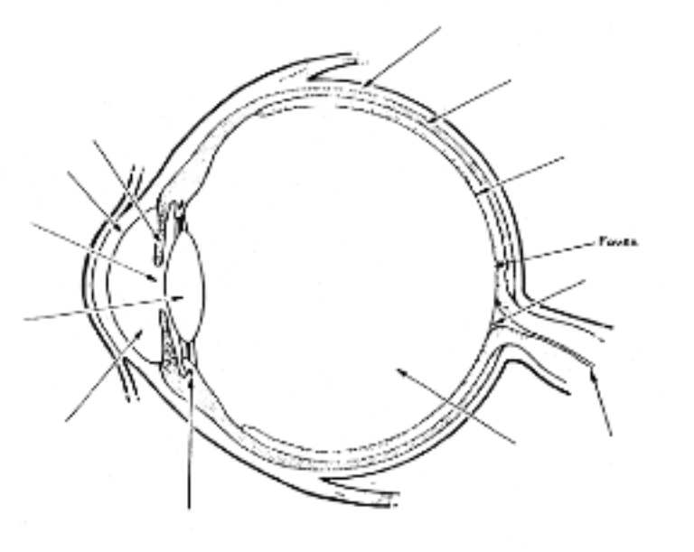
(b) Give the major function for each part.

15. Describe how the lens of the eye changes to focus on a close object and a distant object.

16. (a) With the aid of simple diagrams, explain how a person is affected by short sight (myopia) and long sight (hypermetropia).
(b) How is each problem overcome?

17. What is the blind spot in the eye?

